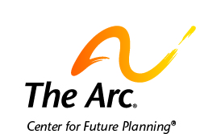

What to Know About Special Needs Trusts and ABLE Accounts

You need to make sure you have money to pay for the things you need.
Special needs trusts and ABLE accounts can help you save money.
The money that you put in them will not hurt your benefits.
Ask people you trust about special needs trusts and ABLE accounts.

Special needs trusts can pay for things that make your life better.
You can get special medical care and service animals.
You can buy assistive technology, phones, and computers.
You can join a gym or take a cooking class.
Money in trusts can also pay for car insurance and vacations.

ABLE accounts can pay for things you need because of your disability.
You can pay for school, a home, and job training.
You can pay for food and transportation.
You can pay for someone to help you at home.
You can pay for a lawyer or someone to help you with your money.

There are specific ways to set up trusts and ABLE accounts.
People who set them up must know the rules about them.
You should talk with family and friends about how to do this.
You can also contact The Arc for more information.

Contact us if you need help.
The Arc’s Center for Future Planning
futureplanning@thearc.org
800-433-5255

